Client Email Follow-Up Series
Feel free to change these emails as you see fit but remember that the more you brand and connect personally with the prospect, the better.
Use an email program like Mailchimp.com (free) if you don’t have one to set these up…
Day 0 - Initial Deliverable Email (where you give them that juicy giveaway they signed up for) – Email subject – Thanks first name, here’s your cheat sheet
Hey %first%,
Thanks so much for signing up for my “Design Cheat Sheet”! If you weren’t able to go to the download page, here’s the direct link:
Put direct link here
Understanding the principles of good design in your remodel project will help to provide a framework for your decisions.
- Don’t purchase that oversized chair if the couch is not of similar scale
- Scale your art purchases to the space on the wall and gallery the art if the wall is too large for the single art piece
- Consider your traffic flow and make sure the furnishings in the room feel balanced
It’s funny because while most people could not name these design principles…we can all tell when the room feels “off” and a principle has been broken. Hope the Cheat Sheet helped.
Cheers to you and your design project!
Warm Regards,
Audra Slinkey - Expert E-Designer
www.yourwebsite.com
P.S. – If you want to FaceTime chat about your project, click here to sign-up for a Free Design Discovery Call

Day 4 Idea – Common color mistakes people make…
Hey %firstname%,
Going through a remodel is not easy but it is a lot of fun! In case you missed it, here’s the link to that Design Principle Cheat Sheet you signed up for:
Put direct link here
One thing I always recommend to my client’s right away is to find rooms online (or even elements of a room) that you like and save them to a Pinterest board (with notes). This way when the contractor asks you “what kind of fireplace surround/crown molding/paint color do you want”…you can show them the photo.
Whatever you do…don’t let them make the decision for your design! A design mistake can be costly and most every remodel is fraught with design pitfalls.
For instance, one of the biggest mistakes I see people make is with color because each neutral type of color (white, beige or gray), looks best with other certain types of color:
- White walls need a lot of texture and organic elements in the space to make it work (otherwise it will look like your first apartment)
- Certain gray colors do not get along with northern exposed rooms (the natural lighting will make it look like a mental hospital…yuck)
- Don’t get me started with beige or yellow-beige…my first paint mistake of a creamy colored space looked more like a school bus
Hope some of these design tips help!
Warm Regards,

Day 8 – Subject of email: Here’s a “Budget Cheat Sheet” to help you first name
Dear %firstname%,
I can’t tell you how often I see people’s budget add up on a remodel project without them even realizing it! Or they will blow their budget entirely on that perfect light fixture only to have nothing left for the rest of the space.
This happens because most people don’t budget ahead of time and have no idea how much certain items cost…until they start shopping. I get it…how are you supposed to know how much things cost?!
Queue the helpful designer…
Here’s the best way to plan your budget for items in the space:
- Look through the space and decide what you want to stay (the most important things that you love about the space)
- Use my Budget Cheat Sheet below and begin to calculate the “replacement cost” of those items you are looking to replace. For those of you with larger budgets who want Bespoke or Designer Product simply double the Restoration Hardware price.
- Add up your budget and voila!

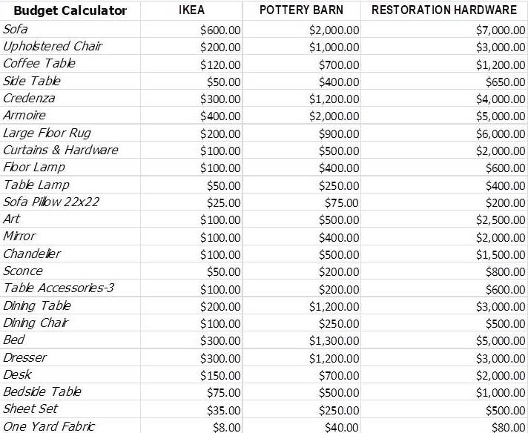
Now doesn’t that make you breathe a little easier?
The key to every good design plan is…planning. I can help you create a design plan based on your space very easily that will also FIT YOUR BUDGET…how cool is that?
If you want to start that conversation for free, click on the button below to schedule your Free Design Discovery Call and let’s chat…
What’s fun about that call is that we get to dream a little about your space while making sure it reflects your personal style, as well as suits the way you live.
Cheers to you and your design project!
Warm Regards,
Audra Slinkey - Expert E-Designer
www.yourwebsite.com
P.S. – If you want to see what a Design Plan in action looks like, click here (link this to your E-Design website page)

Day 15 –
Share a story about a client who did not plan and how the design didn’t work out…etc.. stories resonate with people. Close this email with a picture of one of your boards and how with an E-Design Plan, those mistakes can be avoided.
Day 22 – Tips on Shopping Online

